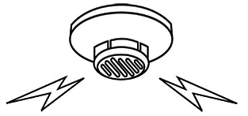
NOTICE
Dear. TAMASUKE BLDG. residents
According to the fire law, We’ll inspect fire fighting equipment.
Please note that：
①The bell rings when we inspect.
②we’ll enter all of rooms to inspect the fire detectors on the ceiling(including those in the closet).
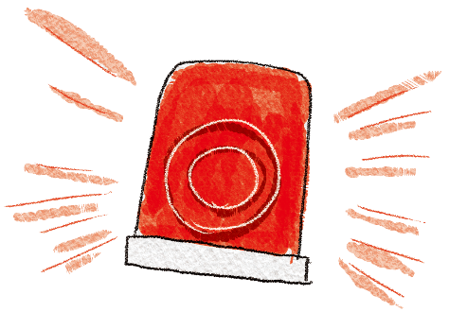
If you are not at home when we visit, we’ll enter your room with the building owner.
Thank you for your cooperating.

Inspection date：09/Sept/2020 AM 9:00 ~ PM 5:00
※If you cannot stay in your room, please contact to the following our phone number.
【Owner】
TAMAMASUKE Co.
【Worker】
Aokibosai Co. ☏ 06-6795-2664
5-chome-6-15 Hirano Honmachi, Hirano-ku, Osaka

